# Adding Spring Security

# Adding Spring Security

*In a Spring boot application, we only need to include the spring-boot- starter-security dependency and Spring boot auto-configured the security with sensible defaults defined in WebSecurityConfiguration class.*

# Authentication and Authorization

**Authentication** is the process of verifying the identity of a user. It ensures that the user is who they claim to be. Authentication typically involves validating credentials, such as a username and password, and creating a security context for the user.

**Authorization** is the process of determining whether an authenticated user has the necessary permissions to access a particular resource or perform an action. It controls what an authenticated user can or cannot do.

# Internal working of Spring-Security

In a Spring Boot application, SecurityFilterAutoConfiguration automatically registers the DelegatingFilterProxy filter with the name springSecurityFilterChain

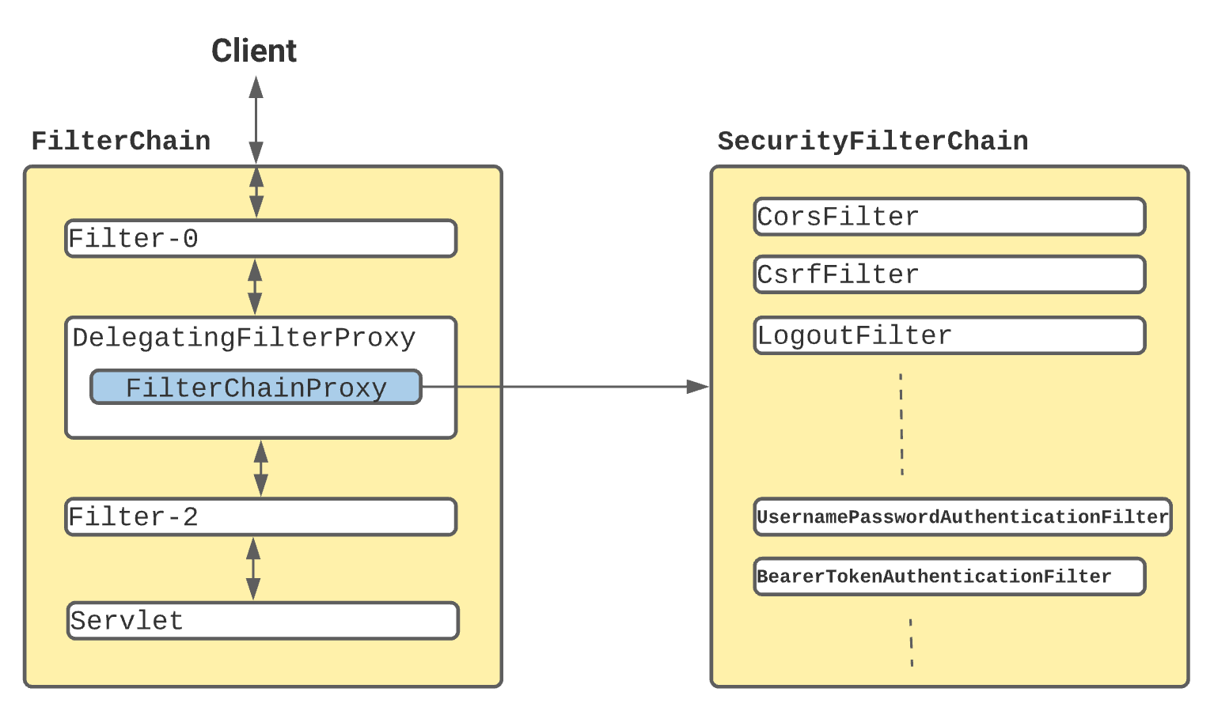

Once the request reaches to DelegatingFilterProxy, Spring delegates the processing to FilterChainProxy bean that utilizes the SecurityFilterChain to execute the list of all filters to be invoked for the current request

Default behaviour of Spring-Security

-Creates a bean named springSecurityFilterChain. Registers the Filter with a bean named springSecurityFilterChain with the Servlet container for every request.

HTTP basic authentication for authenticating requests made with remoting protocols and web services.

Generate a default login form.

Creates a user with a username of user and a password that is logged to the console.

Protects the password storage with BCrypt.

Enables logout feature.

Other features such as protection from CSRF attacks and session fixation

**Internal Flow of Spring-Security**

